KNOWLEDGE PRACTICE AND COVERAGE SURVEY
REPORT
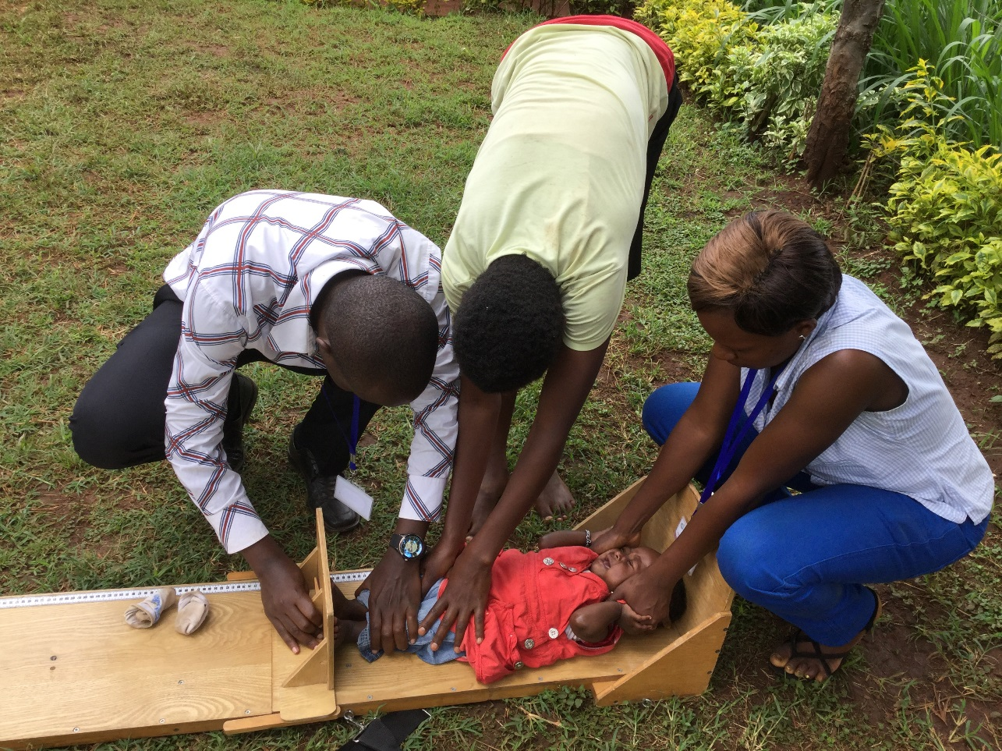
KITUTU CHACHE SOUTH SUBCOUNTY
KISII COUNTY

REPORT BY JAMES NIRU
INDEPENDENT CONSULTANT

MARCH 2018

Abbreviations/Acronyms
ACT Artemisinin-based Combination Therapy
AL Artemether-Lumefantrine
ANC Ante-Natal Care
AMTSL Active Management of Third Stage Labour
BCG Bacille Calmette Guerin
CBC Community Birthing Centre
CHC Community Health Committee
CHEW Community Health Extension Worker
CHMT County Health Management Team
CHV Community Health Volunteer
EBF Exclusive Breastfeeding
HAZ Height-for-Age Z-scores
HH Household
IFAS Iron & Folic Acid Supplementation
IYCF Infant and Young Child Feeding
KPC knowledge, Practice and Coverage
MCH Booklet Mother & Child Health Handbook
MNCH Maternal, New-born and Child Health
ODK Open Data Kit
OPV Oral Polio Vaccine
POU Point of Use
SCHMT Sub-County Health Management Team
SD Standard Deviation
VAS Vitamin A Supplementation
WAZ Weight-for Age
WFH Weight-for-Height

Acknowledgement
First, I would like to thank the Curamericas Global team led by Ira Stollack and Kevin Kayando for giving me the opportunity to spearhead the KPC survey. I acknowledge the special contribution of Ira in the development of KPC methodology, questionnaire and reviewing of the report. I am grateful to Kevin and his team who ensured that all logistics required for the survey were available in a timely manner. I also thank Curamericas Global for funding the survey and the maternal, new-born and child health project in Kisii county. Secondly, I wish to thank the County Health Management Team of Kisii county by participating in the validation of the survey methodology as well as taking active role in supervision of enumerators during data collection. My sincere appreciation goes to Mr Makori, the public health for Kitutu Chache South for his tireless effort for household listing and mobilizing the community through the village elders.
More importantly, my gratitude goes to the enumerators who traversed the sub-county looking for the sampled households to collect quality data without tiring.
Finally yet importantly, I would like to thank my research assistants Mary Okello and Stanley Macharia for their crucial support during the coding of questionnaire and training of enumerators on the ODK.

Executive summary
The health and nutrition situation in Kisii County are worse than the national average, especially the child mortality rate (60 per 1,000 live births), the infant mortality rate (43 per 1,000 live births) and neonatal mortality rate (23%). Contributing to this high maternal mortality are the “four delays”: 1) delay in family recognition of an obstetric complication; 2) once recognized, family delay seeking medical attention; 3) delay securing transportation to a health facility; and 4) once at the health facility, delay in receiving treatment. To respond to the gaps, Curamericas Global and MOH initiated the Community Birthing Centre project aiming to improving attention to obstetric emergencies, preventing and treating postpartum haemorrhage, improving immediate neonatal care, and reducing stunting in under-2 children. The KPC survey was undertaken to gather baseline data for the project indicators.
The survey employed a cross-section design with quantitative data collection using structured questionnaire targeting mothers of children aged 0-23 months. A 30 clusters x 10 HHs (300 HHs) stratified cluster sampling method was used. Data was collected using ODK and uploaded onto ONA. The survey team comprising of 12 enumerators and 4 supervisors were trained for 5 days with two rounds of questionnaire pre-test exercises. Data was analysed using Epi Info version 7.
Summary of key results are presented in Table 1 & 2 below.
Table 1: IYCF and nutrition status
Indicator | Num | Denom | % | 95% CI
Exclusive breastfeeding (24hr recall) | 66 | 88 | 75 | 64.6-83.5
Exclusive breastfeeding (at 6months) | 49 | 76 | 64.5 | 52.7-75.1
Timely initiation of BF | 202 | 301 | 67.1 | 56.3-77.5
Dietary diversity | 99 | 213 | 46.5 | 39.6-53.4
Meal frequency | 5 | 213 | 2.3 | 0.77-5.4
Minimum acceptable diet | 0 | 213 | 0 | 0
Stunting | 46 | 299 | 15.4 | 11.8-19.9
Underweight | 14 | 301 | 4.7 | 2.8-6.3
Wasting | 7 | 297 | 2.4 | 0.9-6.3

Table 2: Summary of key indicator results
 | All |  |  |  | IRANDA |  |  |  | MATONGO |  |  |  | MOSOCHO MARKET
 | Total(N=301) |  |  |  | (n=110) |  |  |  | (n=70) |  |  |  | (n=121)
Indicator description | Num | Denom | % | 95% CI | Num | Denom | % | 95% CI | Num | Denom | % | 95% CI | Num | Denom | % | 95% CI
Health facility delivery (N=301) | 278 | 301 | 92.4 | 88.8 - 94.8 | 102 | 110 | 92.7 | 86.2-96.8 | 65 | 70 | 92.8 | 84.1-97.6 | 111 | 121 | 91.7 | 85.3-96.0
Any ANC checks verified by MCH booklet | 278 | 301 | 92.4 | 88.8-94.9 | 102 | 110 | 92.7 | 86.2-94.9 | 67 | 70 | 95.7 | 88-99.1 | 109 | 121 | 90.1 | 83.3-94.8
1-3 visits | 153 | 278 | 50.8 | 45.2-56.4 | 57 | 110 | 51.82 | 42.1-61.5 | 35 | 70 | 50 | 37.8-62.2 | 61 | 121 | 50.4 | 41.2-59.6
>/=4 visits | 125 | 278 | 41.5 | 36.1-47.2 | 45 | 110 | 40.91 | 31.6-50.7 | 32 | 70 | 45.7 | 33.7-58.1 | 48 | 121 | 39.7 | 30.9-49.0
No ANC Visit | 23 | 301 | 7.6 | 5.2-11.2 | 8 | 110 | 7.3 | 3.2-13.8 | 3 | 70 | 4.3 | 0.9-12.0 | 12 | 121 | 9.9 | 5.2-16.7
Any ANC Visits as reported by informants
0-3 VISITS | 176 | 301 | 58.5 |  | 65 | 110 | 59.1 |  | 38 | 70 | 54.3 |  | 73 | 121 | 60.3
>/=4 visits | 125 | 301 | 41.5 |  | 45 | 110 | 40.9 |  | 32 | 70 | 45.7 |  | 48 | 121 | 39.7
Male partner accompanying their women to ANC | 109 | 301 | 36.2 | 31.0-41.8 | 43 | 110 | 39.1 | 29.9-48.9 | 25 | 70 | 35.7 | 24.6-48.1 | 41 | 121 | 33.9 | 25.5-43.1
Had birth plan in place | 183 | 301 | 60.8 | 55.2-66.1 | 68 | 110 | 61.8 | 52.7-70.9 | 39 | 70 | 55.7 | 43.3-67.6 | 76 | 121 | 62.8 | 53.6-71.4
Birthplan with none or <3 components | 237 | 301 | 78.7 |  | 86 | 110 | 78.2 |  | 57 | 70 | 81.4 |  | 94 | 121 | 77.7
Birthplan with >3 components | 48 | 301 | 16 |  | 16 | 110 | 14.5 |  | 11 | 70 | 15.7 |  | 21 | 121 | 17.4
Birthplan with >4 components | 13 | 301 | 4.3 |  | 7 | 110 | 6.4 |  | 1 | 70 | 1.4 |  | 5 | 121 | 4.1
Birthplan with >5 components | 3 | 301 | 1 |  | 1 | 110 | 0.9 |  | 1 | 70 | 1.4 |  | 1 | 121 | 0.8
Attention to obstetric complications | 81 | 92 | 88.0 | 79.6-93.9 | 33 | 38 | 86.8 | 71.9-95.6 | 21 | 22 | 95.5 | 77.2-99.9 | 27 | 32 | 84.4 | 67.2-94.7
Respectful, culturally appropriate care (N=278) | 54 | 301 | 19.4 | 14.0-22.7 | 18 | 110 | 16.4 | 10.0-24.6 | 8 | 70 | 11.4 | 5.1-21.3 | 28 | 121 | 23.1 | 16.0-31.7
Knowledge on danger signs
at least any 3 danger signs during pregnancy | 79 | 301 | 26.3 | 21.6-31.5 | 27 | 110 | 24.6 | 16.8-33.7 | 22 | 70 | 31.4 | 20.9-43.6 | 30 | 121 | 24.8 | 17.4-33.5
at least any 3 danger signs during post-partum | 53 | 301 | 17.6 | 13.7-22.3 | 15 | 110 | 13.6 | 7.8-21.5 | 21 | 70 | 30.0 | 19.6-42.1 | 17 | 121 | 14.1 | 8.4-21.5
at least any 3 Newborn danger signs | 92 | 301 | 30.6 | 25.6-36.0 | 25 | 110 | 27.2 | 15.3-31.7 | 23 | 70 | 32.9 | 22.1-45.1 | 44 | 121 | 36.4 | 27.8-45.6
Essential New-born Actions
Medicine/Chlorhexidine in the cord | 66 | 301 | 21.6 | 17.6-26.4 | 26 | 110 | 23.6 | 16.1-32.9 | 17 | 70 | 24.3 | 14.8-36.0 | 23 | 121 | 19.0 | 12.5-27.1
Dried and wrapped with warm cloth/blanket | 256 | 301 | 85.1 | 80.6-88.6 | 96 | 110 | 87.3 | 79.6-92.9 | 60 | 70 | 85.7 | 75.3-92.9 | 100 | 121 | 82.6 | 74.7-88.9
Placed skin-to-skin on the mother’s abdomen | 3 | 301 | 1 |  | 2 | 110 | 0 |  | 0 | 70 | 0 |  | 1 | 121 | 0.8
Immediately after/within the first hour | 202 | 301 | 67.1 | 61.6-72.7 | 74 | 110 | 67.3 | 57.7-75.9 | 54 | 70 | 77.1 | 65.6-86.3 | 74 | 121 | 61.2 | 51.9-69.9
Baby weighed (N=301) | 270 | 301 | 89.7 | 85.8-92.7 | 101 | 110 | 91.8 | 85.0-96.2 | 63 | 70 | 90 | 80.5-95.9 | 106 | 121 | 87.6 | 80.4-92.9
Baby measured length | 51 | 301 | 16.9 | 13.1-21.6 | 26 | 110 | 23.6 | 16.1-32.7 | 9 | 70 | 12.9 | 6.1-23.0 | 16 | 121 | 13.2 | 7.8-20.6
Active Management of Third Stage Labour | 145 | 288 | 50.4 | 43.7-55.6 | 50 | 105 | 47.6 | 37.8-57.6 | 38 | 69 | 55.1 | 42.6-67.1 | 57 | 114 | 50 | 40.5-59.5
Handwashing when | 245 | 301 | 81.4 | 76.6-85.4 | 90 | 110 | 81.8 | 73.3-88.5 | 56 | 70 | 80 | 68.7-88.6 | 99 | 121 | 81.8 | 73.8-88.4
Proper point-of-use (POU) water treatment | 33 | 301 | 11.0 | 7.9-15.0 | 14 | 110 | 12.7 | 7.1-20.4 | 9 | 70 | 12.9 | 6.1-23.0 | 10 | 121 | 8.3 | 4.0-14.7
Proper water storage | 148 | 301 | 49.2 | 43.6-54.8 | 59 | 110 | 53.6 | 43.9-63.2 | 40 | 70 | 57.1 | 44.8-68.9 | 49 | 121 | 50.4 | 31.7-49.8
Proper faeces disposal | 288 | 301 | 95.7 | 92.8-97.5 | 105 | 110 | 95.5 | 89.7-98.5 | 66 | 70 | 94.3 | 86.0-98.4 | 117 | 121 | 96.7 | 91.8-99.1
Open Defecation Free (ODF) Household | 31 | 301 | 10.3 | 7.4-14.3 | 12 | 110 | 10.9 | 5.8-18.3 | 3 | 70 | 4.3 | 0.9-12.0 | 16 | 121 | 13.2 | 7.8-20.6
Illness in last 2 weeks | 130 | 301 | 43.2 | 37.7-48.8 | 55 | 110 | 50 | 40.3-59.7 | 34 | 70 | 48.8 | 36.4-60.8 | 41 | 121 | 33.9 | 25.5-43.1
Proper treatment for diarrhea- ORS | 5 | 130 | 0.04 |  | 2 | 55 | 3.6 |  | 3 | 34 | 8.8 |  | 0 | 41 | 0
Immunization of young children (12 months) | 166 | 176 | 94.3 | 89.8-97.2 | 65 | 68 | 95.6 | 87.6-99.1 | 41 | 43 | 95.4 | 84.2-99.4 | 60 | 65 | 92.3 | 83.0-97.5
Treatment with ACT for malaria | 9 | 13 | 69.2 | 38.6-90.9 | 2 | 4 | 50.0 | 6.8-93.2 | 1 | 1 |  |  | 6 | 8 | 75.0 | 34.9-96.8
Proper/timely care-seeking for pneumonia (N=44) | 18 | 44 | 40.9 | 26.3-56.7 | 12 | 21 | 57.1 | 34.0-78.2 | 6 | 14 | 42.9 | 17.7-71.1 | 0 | 0
Child Vitamin A supplementation | 125 | 213 | 58.7 | 51.8-65.4 | 46 | 72 | 63.9 | 51.7-74.9 | 22 | 52 | 42.3 | 28.7-56.8 | 57 | 89 | 64.0 | 53.2-74.0
Child Vitamin A supplementation (6-12months) | 45 | 88 | 51.1 | 40.3-62.0 | 14 | 30 | 46.7 | 28.3-65.7 | 9 | 25 | 36.0 | 18.0-57.5 | 22 | 33 | 66.7 | 40.3-62.0
Child Vitamin A supplementation 13-23 months (N=125) | 80 | 125 | 64.0 | 54.9-72.4 | 32 | 42 | 76.2 | 60.6-88.0 | 13 | 27 | 48.2 | 28.7-68.1 | 35 | 56 | 62.5 | 48.6-75.1
Child deworming (N=213) | 20 | 213 | 9.4 | 5.8-14.1 | 10 | 72 | 13.9 | 6.9-24.1 | 3 | 52 | 5.8 | 1.2-16.0 | 7 | 89 | 7.9 | 3.2-15.5

Table of Contents
Abbreviations/Acronyms ii
Acknowledgement iii
Executive summary iv
List of Tables viii
List of Figures ix
1. Introduction 1
1.1 Background 1
1.2 Purpose 2
2. SURVEY METHODS 2
2.1. Survey sites and population 2
2.2. Sampling and sample size 2
2.2 Survey planning and organization 3
2.3 Recruitment and training of survey enumerators and supervisors 3
Standardization exercise 3
Pre-test of the questionnaire 4
2.4 ODK data collection 4
ODK setup during the KPC survey 5
2.5 Data collection and field procedures 5
Step 1: 5
Step 2 5
Step 3 6
Step 4: 6
Step 5 6
Step 6 6
2.6 Data quality assurance 6
2.7 Data Analysis 6
3 Results 6
3.1 Pregnant woman and essential new-born care 8
3.1.1 Respectful and culturally appropriate care 10
3.1.2 Birth plan 10
3.2 Management of obstetric complications and C-section 11
3.2.1 Postpartum care 11
3.2.2 FP uptake 11
3.3 Equity and access to delivery services 11
3.4 Maternal lactation, nutrition and micronutrients 13
3.4.1 Infant and young child feeding practices 13
3.5 Nutritional status of children 14
3.6 Water, hygiene and sanitation 15
3.7 Childhood illnesses 16
3.7.1 Diarrhoea treatment 16
3.7.2 Malaria treatment 17
3.7.3 Pneumonia treatment 17
3.8 Immunization 17
3.8.1 Vitamin A supplementation 17
3.8.2 Deworming 17
Annex 18
Annex 1: Outcome indicators of the MNCH project in Kisii 18
Annex 2: Survey map 21
Annex 3: Example of filled cluster control form 22
Annex 4: Movement plan and contacts 22
Annex 5: Calendar of events 23
Annex 6: Training schedule for survey team 23
Annex 7: Sampled villages 28
Annex 8: Work plan 29
Annex 9: Group photo 29
Annex 10: ODK setup 30

List of Tables
Table 1: IYCF and nutrition status iv
Table 2: Summary of key indicator results v
Table 3: Survey population by catchment area 2
Table 4: Demographic characteristics of the respondents 7
Table 5: Maternal and newborn care indicators 8
Table 6: Distribution of obstetric complications by health facility. 11
Table 7: Cost of delivery by age and health facility 11
Table 8: Place of delivery compared to age of the respondent 12
Table 9: Place of delivery compared to distance to health facility 12
Table 10: Equity to health facility access by parity of the women 12
Table 11: Infant and young child feeding practices 13
Table 12: Prevalence of undernutrition based on HFA, WFA, WFH z-scores and sex 14
Table 13: Prevalence of overweight by age, based on weight for height (no oedema) 14
Table 14: Comparison of malnutrition (mean z-scores) by health facility catchment area 15
Table 15: Hygiene, water and sanitation 15
Table 16: Recommended MOH immunization schedule 17

List of Figures
Figure 1: Time taken to administer questionnaire at household 7
Figure 2: Marital status of the respondent 9
Figure 3: Highest education level completed of respondents 10
Figure 4: Culturally acceptable practices employed by health facilities during delivery 13
Figure 5: Components of birth plan 13
Figure 6: Progression of malnutrition by age 17
Figure 7: Distribution of childhood illnesses 19

Introduction

Background
The health and nutrition situation in Kisii County are below the national average, especially the child mortality rate (60 per 1,000 live births), the infant mortality rate (43 per 1,000 live births) and neonatal mortality rate (23%). The Kisii County health authorities acknowledge incomplete data and consistent under-reporting, which contributes to dramatically under-estimated mortality rates for the region. Maternal and neonatal mortality and child malnutrition are of specific concern. The 2011 MICS found that 23% of children under age five were underweight (WFA<-2 Z-scores) with 35% stunted (HFA<-2 Z-scores). The MICS also found that only 57.8% of women delivered at the health facility while 36.2% delivered at home, with only 53% attended by skilled personnel. Only 41% of mothers exclusively breastfed their children for at least 5 months; and only 52.5% of married or in union women aged 15-49 used any modern method of family planning. This has resulted in a high Maternal Mortality Ratio (MMR) in Kisii County, estimated at 500 deaths/100,000 births, higher than the Kenyan national MMR of 478. The leading cause of death is post-partum haemorrhage.
Contributing to this high maternal mortality are the “four delays”: 1) delay in family recognition of an obstetric complication; 2) once recognized, family delay seeking medical attention; 3) delay securing transportation to a health facility; and 4) once at the health facility, delay in receiving treatment. The associated factors include lack of family and community preparedness, lack of ambulances and costly transportation, lack of women’s decision-making autonomy, adherence to traditions of home delivery, lack of health facility personnel and resources, and fear of abusive disrespectful treatment at the health facility.
In January 2018, Curamericas Global (Curamericas) and the Kisii County Department of Health (KCDOH) began a three-year maternal, newborn and child health (MNCH) project to respond to the above challenges. The project includes maternal and child health outreach as well as strengthening current health facilities to provide high-quality, culturally-appropriate, respectful care. The project focuses on: 1) improving attention to obstetric emergencies; 2) preventing and treating postpartum haemorrhage; 3) improving immediate neonatal care; and 4) reducing stunting in under-2 children. The overall expected impact is reduction in maternal and neonatal mortality, which, in Kisii County, are both higher than the national rates. The core intervention is the Community Birthing Center (CBC), a partnership between the health facilities attending deliveries and referring complications, and the communities in their catchment.
The project is implemented in the catchments of three Level 2 and 3 health facilities in Kitutu Chache South Sub-County of Kisii County, with a total population of beneficiaries of approximately 50,000, which includes 12,700 women of reproductive age (WRA-defined as 14-49 years of age), 11,980 adolescents (defined as 10-14 years of age), 7,487 children under five years (U5), and 3,743 children under two years (U2).
The approach is community-based utilization; 1) mobilizing communities working in partnership with the local health facility, CHEWs and CHWs; 2) through the community/health facility partnership, adapting existing Level 2 and Level 3 health facilities in the project to the Community Birthing Center Model; 3) training of Traditional Birth Attendants to encourage facility-based deliveries and referral; 4) utilizing village-based volunteers/mother peer educators to disseminate health messages using the Care Group approach; 5) a census-based monitoring and evaluation approach utilizing Curamericas Global’s Community-Based Impact-Oriented (CBIO) methodology; and 6) empowering CHWS/CHEWs/CHCs to create an obstetric emergency response system; 7) ensuring women receive respectful, culturally appropriate, and equitable services during maternal care, with focused attention on those most at risk (poorest, least educated, highest parity, and of age outside of prime child-bearing years (adolescents and women over 35).
The Knowledge, Practice and Coverage (KPC) household survey provided baseline data for the outcome indicators in the three project catchments to measure progress.

Purpose
The purpose of the Knowledge, Practice and Coverage (KPC) household survey in the three project catchments was used to obtain baseline data for the outcome indicators shown in Annex 11.

SURVEY METHODS
The survey was cross-section and employed quantitative data collection method using structured questionnaire targeting mothers of children aged 0-23 months.

Survey sites and population
The survey was conducted in catchments of Iranda health center, Matongo and Mosocho Market dispensaries in Kitutu Chache South Sub-County, Kisii County with approximate population of 50,000, with projected 12,700 women of reproductive age (WRA-defined as 14-49 years of age), 11,980 adolescents (defined as 10-14 years of age), 7,487 children under five years (U5), and 3,743 children under two years (U2). Table 3 shows population of the three catchments areas.
Table 3: Survey population by catchment area
Catchment Area | Population | Women with children <2yrs
Iranda | 16,464 | 1,581
Matongo | 12,537 | 1,204
Mosocho Market | 20,909 | 2,007
Total | 49,910 | 4,791

Sampling and sample size
The 30 clusters x 10 HHs (300 HHs) stratified cluster sampling method was selected because it provides more accurate representation of the 55+ communities and/or villages in 3 catchments than other sampling methods. This was informed by the higher cluster design effect assumed in the survey area because of the distinct socio-economic characteristics of the communities. A cluster was considered a village.
A two-stage sampling design was used. The 1st stage involved systematic sampling of villages from sampling frame of all villages and their populations in the three catchment areas. Total number of clusters required was 30. A sampling interval was calculated to obtain a quasi-random method for assigning clusters by dividing the cumulative population by 30. i.e. the total population of the three catchment areas of Iranda, Matongo & Mosocho Market was 49,910. Therefore, 49,910/30 = 1663.7 ≃ 1664. Therefore, every 1664th unit (village) was selected. One village (Nyonsia A-F) that had population above 3,827 was assigned 2 clusters.
The 2nd stage involved simple random sampling of 10 mothers of under-2 children from a village list of HHs with children 0-23 months old maintained by the village CHV. The village lists with names of the household head or caregivers of children <2yrs old were generated one week prior to the survey. The SRS of HHs was done using Random Number Generator software installed in all the tablets used to collect data. The sampling unit was the mother/caregiver of a child 0-23 months old in a household. Ten mothers per selected community cluster were randomly selected from the list for interviewees. When a mother/caregiver had more than one child aged 0-23 months, the youngest child was selected to minimize mothers recall bias regarding health and nutrition care services received during (pregnancy, delivery, postpartum and infant and young child feeding), the 1st 1000 days duration from conception to 2 years after delivery. Further, the younger child is more vulnerable to childhood illnesses and thus was suitable to provide better morbidity patterns than older children in the same household. The sampled clusters/villages are shown in Annex 6.

Survey planning and organization
Planning of the survey started one month prior to survey date. The preliminary steps undertaken involved development of the Scope of Work (SOW) by Curamericas Global program technical director and the Kenyan based project staff. The SOW comprised the objectives of the three-year maternal, new-born and child health (MNCH) project, Terms of Reference (TOR) for hiring the consultant and the indicators to be included in the survey. The consultant was brought on board three weeks prior to the start of the survey. The project coordinator identified, interviewed and recruited the enumerators one week before the training. The choice of the cluster sampling design adopted for the KPC survey was discussed and agreed upon between the consultant and the technical program director based on the merits in improving the representation due to higher number of clusters to be involved compared to the LQAS or other methods.

Recruitment and training of survey enumerators and supervisors
The survey team comprised of 12 enumerators (5 Curameriaca’s staff, 7 others) 4 supervisors (County Health Management Team-MOH staff) and a survey coordinator (consultant). The seven enumerators were interviewed and vetted by Curamericas project coordinator based on their education background and experience in data collection of health and nutrition projects. All the enumerators had a post-secondary education and had at least participated in data collection in the past. They all resided within Kitutu Chache South, Kisii county and were familiar with the survey areas. Majority were fluent in local dialect – Kisii language, as well as Kiswahili. The four supervisors involved in the survey were selected from the county and sub-county health management teams of the county department of health.
The survey team was trained by the consultant for 5 days from 19th March to 23rd March 2018. The county public health nurse and nutrition coordinators facilitated delivery, new-born and infant, and young child feeding modules of the questionnaire respectively. The training was held in Magaribi training hotel in Kisii town. The training curriculum was adopted from the KPC survey 2000+ field guide training modules. The main topics covered included the objectives of the maternal, new-born and child health project “The Community Birthing Centre”, interviewing techniques, survey ethics and sampling and questionnaire. The first 2 days focused on the mastery of the questionnaire, anthropometry measurements, introduction to ODK & tablets including translation into Kiswahili and local language (Kisii). The questionnaire was translated into Kiswahili and Kisii during the classroom training by the local enumerators and CHMTs. Consensus on how the questions should read and asked in Kiswahili and Kisii was reached in plenary. The Kiswahili and Kisii versions of the questionnaire were printed for role play in the class and validation was done by the CHMT members.

Standardization exercise
The standardization exercise was conducted in a nearby school where 13 mothers with children <2 years had been mobilized to assemble. The consultant and the supervisors measured the weight, length and MUAC and recorded the measurements of children without allowing enumerators to see the measurements. The enumerators were paired based on previous experience to anthropometry measurements. The supervisors observed each pair when taking measurements of the same children in turns and recorded the readings. Each enumerator took two measurements on the same child. The consultant and supervisors provided prompt feedback to the enumerators. The enumerators who emerged poor from standardisation test were paired with best performing enumerators and were further mentored during the pre-test exercises.

Pre-test of the questionnaire
The team was taken through two rounds of field pre-test of the questionnaire on 2nd and 4th days of the training. The objectives of the pre-test included;
- To test the flow of the questions and the skip pattern
- Establish the time taken to administer the questionnaire
- To exercise taking anthropometry measurements weight, length and MUAC
- To acquaint the enumerators on the use of tablets and ODK forms, saving completed forms and uploading the completed forms.
- To practice seeking the consent
The training methods used were lecture, demonstration, exercises, Q&A, role plays and practical sessions.
The results of the 1st and 2nd pilot are shown in Figure 1 below. The median time taken to administer the questionnaire reduced by 10 minutes in the 2nd pilot.

Figure 1: Time taken to administer questionnaire at household

ODK data collection
The Open Data Kit (ODK) system provides a framework for implementing field data gathering campaigns, it enhances the information management capabilities using mobile devices (Android O.S.) for data collection and monitoring purposes. One of the main advantages of the system is that it allows data gathering and analysis with or without internet connectivity. The following are required for ODK data collection:
- The data collection tools – the questionnaires
- User account in ONA or KOBO with the necessary credentials
- Internet enabled Android devices e.g. Internet enabled tablets with a big screen size like 10’’ for proper visibility while in use, an appropriate storage memory size and a good quality camera for use when required.

ODK setup during the KPC survey
Once the KPC questionnaire was ready for use, it was formatted into an .xls form, which was uploaded onto the ONA account. The consultant validated and verified the xls form after series of dry run exercises. Any errors of the skips and flow in the questionnaire were highlighted and corrected in the xls form. Upon successful uploading, a web form of the questionnaire was generated for preview.
On the tablets, the ODK collect App was installed and configured to match the credentials of the consultant’s user account set up. Using the “Get blank form” tab on the tablets, the uploaded data collection form was loaded onto the tablets ready for use. For this to work, the device was connected to the internet. However, when collecting the data, the tablets needed not be connected to the internet. The enumerators filled up as many forms as possible and save them on the device then uploaded them when they got internet connection. The supervisors were provided with data bundles in their mobile phones where all tablets of the group were tethered via WiFi hotspot and saved forms were submitted to the server in the consultant ONA account. The GPS tagging of the respondents locations was enabled in the tablets to automatically collect the GPS coordinates as well as the date of data collection and the device ID.
The submitted data was retrieved on a real time basis from the user account set up and downloaded in different formats like .csv, .xls or .sps formats. This was then exported to Epi Info, ENA for SMART and SPSS analytical software. Various checks were put in place to ensure the data submitted was clean and high quality and required very minimal or no cleaning before it being ready for use.

Data collection and field procedures
The county and sub-county public health office and community health strategy focal person supported by Curamericas staff mobilized the village elders and CHVs in the sampled clusters to prepare them for the survey. The CHVs and village elders were engaged in listing households with children under two years to generate the sampling frame from which the 10 households were selected using SRS. The village elders and CHVs guided the enumerators as they navigated the clusters to visit the selected households to interview the mothers of children less than 2 years.
The questionnaire was coded and uploaded into tablets using Open Data Kit (ODK) software. The 12 enumerators were grouped into six teams based on their performance skills assessed during classroom training. The enumerators knowledge and skills on the mastery of the questionnaire and interviewing techniques were evaluated through oral test-questions and direct observation during classroom exercises and pre-test of the questionnaires. The criteria used in the team’s formation include; skill in taking anthropometry measurements, ability to speak and understand local dialect and knowledge of geography of the study area. Those with better skills in anthropometry, local dialect and geography were matched with weaker ones to complement each other. Each team comprised of 2 enumerators and one team leader.
The teams followed the following steps during data collection:
Step 1: Clusters allocation. Each team was allocated 5 clusters (50 households). The cluster allocation was done during the training to allow teams to consult amongst themselves and local administration on the routing to access the clusters.
Step 2: Random household section. All household heads and/or mothers or caregivers of children aged 0-23 months were listed by CHVs or village elder one week prior to the data collection. Before visiting the cluster, the team randomly select 10 households from the cluster households list using the Random Number Generator in the tablets. The process of randomly selecting the 10 HHs was as follows; indicate the minimum and maximum numbers from the household list and then input 10 as the number of integers to be generated in the how many numbers do you need window and select “None” in the window Exclude these numbers then click Generate.
Step 3: Record the number and name of the household head or the mother/caregiver on the notebook with the corresponding household number in the cluster household listing.
Step 4: Upon arrival in the cluster, each team leader read out to the cluster guide/CHV the names of the mothers they had randomly selected from the village lists that they needed to visit and asked whether he/she knew their location. The team started with nearest household and visited all the ten households listed.
Step 5: Introducing the team in the household and seeking consent. The team leader introduced the team to the household head and/other members and explained them the details of the survey and administered the consent form. If the household mother agreed to be interviewed, she was asked to sign/thumb print the consent form in duplicate. The respondent retained one copy while the other copy was handed over to the team leader. The ten signed consent forms and the cluster control form of all 30 clusters were submitted to the project coordinator in Curamericas Global office.
Step 6: Replacing a household. If the household or the respondent (mother/caregiver could not be found, a re-visit would be scheduled in the afternoon or in the following day before the team left the cluster. If the respondent was unavailable for the interview in the re-visit, the enumerators informed the team leader who in turn informed the supervisor and an agreement to replace the household would be reached. Then Step 2 would be repeated only to randomly select replacement household(s) by excluding all the numbers generated in the first round.

Data quality assurance
The intensive 5-day training of survey teams coupled with two rounds of pre-test of the survey questionnaire enhanced the quality of data collection. The use of tablets and ODK enabled us to develop quality checks such as skip patterns, age limits and filters, which greatly minimize errors during data collection. Thus, the enumerators could concentrate on interviewing and active engagement with the respondent. The daily debrief meetings every morning enabled the supervisors and the survey coordinator to address field operational challenges. The online real-time data access and scrutiny by the consultant as it streamed into the server enabled identification of any errors of omission or commission by the enumerators. The ODK also helped the consultant to track the completed and submitted questionnaires everyday verifying the supervisors’ reports. The survey coordinator corrected errors in a timely manner. Any missing data was identified before the team completed the cluster and thus enumerators revisited to collect the missing data. The strong supervision of the teams and clear roles and responsibility with execution plan shared and discussed prior to going to the field contributed to improved quality of data.

Data Analysis
Anthropometry data was downloaded from the ODK server in xls format and exported to ENA for SMART software version July, 9th 2015. The anthropometry indices were then integrated into master spreadsheet used for Epi Info analysis. All other indicators were analyzed using Epi Info software version 7.

Results
A total of 301 mothers with children aged 0-23 months were interviewed. The median age of the respondents was 24 years and majority (82%) were living together in a marriage union as shown in Figure 2 below.

Figure 2: Marital status of the respondent

Although majority of the respondents have some formal education, less than a quarter and a fifth of them completed primary and secondary education, respectively.

Figure 3: Highest education level completed of respondents

Farming is the most common occupation practiced by 32% of the respondents followed by own business and casual labour at 14%. About 90% of the respondents were lactating at the time of the survey. Table 4 shows the demographic characteristics of the respondents.
Table 4: Demographic characteristics of the respondents
Characteristic of the respondent (N=301) |  | n | % | 95% C.I
Age (years) n=301 | Median | 24
 | Mean | 23.6 ±8.7
 | Range | 26
Highest education attained | Some Primary | 81 | 26.9
 | Primary completed | 65 | 21.6
 | Some secondary | 65 | 21.6
 | Secondary completed | 57 | 18.9
 | Post-secondary | 29 | 9.7
Language | Kisii | 144 | 47.8 | 42.2 - 53.5
 | Kiswahili | 138 | 45.9 | 40.3 - 51.5
 | English | 10 | 3.3 | 1.8-6.0
 | Luo | 9 | 3.0 | 1.6 - 5.6
Marital status | Married | 247 | 82.1 | 77.3 - 86.0
 | Single | 40 | 13.3 | 9.9 -17.6
 | Separated | 8 | 2.7 | 1.4 - 5.2
 | widowed | 4 | 1.3
Current occupation | Farming | 97 | 32.2 | 27.2 -37.7
 | Own business | 44 | 14.6 | 11.1-19.1
 | Casual labour | 43 | 14.3 | 10.8 -18.7
 | Informal employment | 36 | 11.9 | 8.8 -16.1
 | Housewife | 27 | 8.9 | 6.2 - 12.7
 | Dependent | 18 | 6.0 | 3.8 -9.3
Physiological status | Lactating and not pregnant | 265 | 88.0
 | Not pregnant and not lactating | 30 | 10.0
 | Pregnant/pregnant and lactating | 6 | 2.0
Age (yrs) at first pregnancy | Mean | 19.02±3.7

Pregnant woman and essential new-born care
Pregnant women should go for antenatal checks at health facility every month. It is recommended that pregnant women attend at least four focused antenatal visits to health facility to be checked by a health professional. Table 5 shows services received by mothers during their most recent pregnancy.
Table 5: Maternal and newborn care indicators
Item | Indices | Num | Denom | % | 95% CI
Health facility delivery (N=301) | Public/private health facility | 278 | 301 | 92.4 | 88.8 – 94.9
 | At home assisted by TBA | 12 |  | 4
 | Others | 11 |  | 3.6 | 5.2 - 11.2
Antenatal checks made during last pregnancy verified by MCH booklet (N=278) | 4+ | 125 | 278 | 45 | 39.0 -51.0
 | <4 | 153 |  | 55 | 49.0 - 61.0
ANC Visits N=301 as reported by informants | 4+ | 125 | 301 | 41.5 | 36.1- 47.2
 | <4 | 176 |  | 58.5 | 52.8 - 63.9
Male partner accompanying their women to ANC | At least once | 109 | 301 | 36.2 | 31.0 - 41.8
 | 2-3 times | 36 |  | 12
 | At least 4 times | 10 |  | 3.3
Birth plan consisting of minimum criteria | Had a birth plan | 183 | 301 | 60.8 | 55.2-66.1
 | Met all 5 point criteria | 3 | 183 | 1.6 | 0.34% - 4.72%
 | At least any 4 points criteria | 16 |  | 8.7 | 5.08% - 13.81%
 | Atleast any 3 point criteria | 64 |  | 35 | 28.09%- 42.36%
Attention to obstetric complications | Complications during pregnancy, delivery, postpartum treated by a health professional | 81 | 92 | 88.0 | 79.61 – 93.88%
Respectful, culturally appropriate care | Met 5 point criteria (courteous, family presence, choose birth position & attendant, privacy, consuming traditional food/practices | 54 | 278 | 19.4 % | 14.94%-24.57%
Knowledge on danger signs (at least any 3 danger signs) | During pregnancy | 79 | 301 | 26.3 | 21.60% -31.49%
 | During delivery | 0 |  | 0
 | Post-partum danger signs for mother | 53 |  | 17.6 | 13.72-22.31%
 | Post partum danger signs for new-born | 92 |  | 30.6 | 22.63%-35.99%
Essential Newborn Actions | Received all essential new-born actions (ENAs) | 9 | 301 | 3 | 1.58% - 5.58%
 | immediate thermal care (drying and wrapping) | 256 |  | 85.1 | 80.58% - 88.64%
 | immediate breastfeeding (IBF) (within 1 hour) | 202 |  | 67.1 | 61.62% - 72.17%
 | clean cord care | 66 |  | 21.9 | 17.62% - 26.94
 | weighing | 267 |  | 89.7 | 85.75% - 92.65%
 | Length taken | 51 |  | 16.9 | 13.13% - 21.59%
 | Received BCG and OPV0 at birth | 294 |  | 97.5
Active Management of Third Stage Labour | Received AMTSL out of those attended by professional | 145 | 288 | 50.4 | 44.42%-56.27%
 | Received AMTSL out of all women interviewed | 145 | 301 | 48.2 | 42.59% - 53.81%

Respectful and culturally appropriate care
About a fifth (19.4%) of the women interviewed reported that the practices by health workers during delivery were respectful and culturally appropriate. The commonly practiced behaviors in the health facility where women delivered are respectful treatment and provision of privacy during delivery as shown in Figure 4 below.

Figure 4: Culturally acceptable practices employed by health facilities during delivery

Birth plan
The 60.8% of women reported they had a birth plan in their recent delivery. Of those who had a birth plan, only a third (35%) had their birth plan comprising 3 out of the 5 recommended components of a birth plan. Barely 1.6% had a birth plan that met all the five point-criteria of a complete birth plan. The most challenging component of the birth plans to include in the birth plan was Person to care for the home or other children and birth companion recommendations as shown in Figure 5.

Figure 5: Components of birth plan

Management of obstetric complications and C-section
About 30.6% (92) of all women interviewed reported they had an obstetric complication during pregnancy, delivery or postpartum in most recent pregnancy. Out of the 92 reported complications, 88% received attention from health professional. The percentage of women interviewed who reported to have had a complication during pregnancy, delivery, and post-partum in their most recent pregnancy was 1.7% (5). About 8.3% (25) of all women interviewed reported they had a complication in their recent pregnancy. Most of the complications (84%) were delivered through C-section. This represents 7.0% of total deliveries that were through C-section. Table 6 shows the distribution of complications across the three health facilities.
Table 6: Distribution of obstetric complications by health facility.
Complication | # reported in pregnancy | # reported in delivery | # reported in post-partum | Total # reported | Percentage of total deliveries (n=301) | # C-section  (N=301)  (n=25)
Iranda | 30 | 11 | 10 | 51 | 16.9% | 8
Matongo | 19 | 6 | 4 | 29 | 9.6% | 6
Mosocho Market | 27 | 8 | 5 | 40 | 13.3% | 7
Total | 76 | 25 | 19 | 120 | 39.9% | 21 (7.0%)

Postpartum care
The women who reported to have had a complication or discomfort during postpartum period (within 6weeks or 42 days after delivery) were 20.7% (19). Almost two-thirds (63.2%) of those women with complication/discomfort during postpartum are likely to receive postpartum check by a health professional for themselves and their new-born within 48 hours of delivery

FP uptake
Out of the 98% (295) of women who were not pregnant at the time of the survey, 75.6%, CI 70.3 – 80.4% (223) reported to be using family planning method to prevent themselves becoming pregnant and thus space their pregnancies. The commonly used method was shot/DepoProvera (41.0%) followed by Norplants/subcutaneous implants (23.3%). A fifth (20.3%) of the non-pregnant women were not on any family planning method.

Equity and access to delivery services
The median cost of delivery was Ksh 1,500. The huge SD from the mean (4,011.0±12,966.4 shows that some mothers reported to have incurred huge costs of a delivery as shown in Table 7.
Table 7: Cost of delivery by age and health facility
 | IRANDA |  |  | MATONGO |  |  | MOSOCHO MARKET
 | < 20 | 20-34 | 35-49 | < 20 | 20-34 | 35-49 | < 20 | 20-34 | 35-49
Median (IQR) cost of transport | 150 (100-400) | 100 (50-450) | 350 (200-570) | 250 (100-450) | 200 (100-400) | 200 (200-1600) | 150 (60-280) | 140 (70-400) | 200 (50-300)
Median (IQR) healthcare services | 0 (0-1000) | 0 (0-500) | 350 (0-1500) | 400 (0-1850) | 200 (0-2000) | 3700 (1000-8000) | 1900 (0-2500) | 200 (0-2500) | 2000 (0-3000)
Median (IQR) food | 100 (0-300) | 100 (0-250) | 100 (0-500) | 150 (0-500) | 200 (0-500) | 0 (0-300) | 0 (0-250) | 150 (0-500) | 0 (0-500)
Median (IQR) medicine | 0 (0-0) | 0 (0-175) | 350 (0-2500) | 0 (0-240) | 0 (0-0) | 0 (0-500) | 0 (0-0) | 0 (0-500) | 0 (0-0)
Median (IQR) midwife | 0 (0-0) | 0 (0-0) | 0 (0-0) | 0 (0-0) | 0 (0-0) | 0 (0-0) | 0 (0-0) | 0 (0-0) | 0 (0-0)
Median (IQR) Non-pharms | 250 (0-300) | 200 (95-305) | 300 (0-500) | 225 (175-500) | 200 (0-300) | 200 (0-500) | 275 (200-300) | 200 (0-300) | 300 (0-500)
Median (IQR) Other cost | 0 (0-0) | 0 (0-0) | 0 (0-0) | 0 (0-0) | 0 (0-0) | 0 (0-0) | 0 (0-0) | 0 (0-0) | 0 (0-0)
Median (IQR) total cost | 750 (270-2250) | 1000 (430-3050) | 1770 (900-1770) | 1790 (1050-4600) | 2000 (700-3200) | 3800 (2500-30200) | 2215 (1020-3000) | 1950 (800-3700) | 3050 (500-4508)

There is no significant difference in access to health facility with respect to age category as shown in Table 7. This shows that equity was achieved to access delivery services with respect to age, wealth and distance to health facility as show in Table 8 and 9 below.
Table 8: Place of delivery compared to age of the respondent
 |  | Place of delivery
Age group | total | home | Health facility | p-value
< 20 yrs | 37 (13.31%) | 2 (5.4%) | 35 (94.6%) | p>0.5
20-34yrs | 216 (77.7%) | 15 (6.9%) | 201(93.1%)
35+yrs | 25 (9.0%) | 2 (8.0%) | 23 (92.0%)
TOTAL | 278 (100%) | 19 (6.8%) | 259 (93.2%)

Majority of mothers live within 4 km radius to the health facility. There was no difference in accessing health facility between those who lived less than 4 km to health facility and those who lived within 4-8 km as shown in Table 9.
Table 9: Place of delivery compared to distance to health facility
Distance | Place of delivery |  | Total
 | Out of health facility  Num (%) | Health facility  Num (%)
< 4 KM | 21 (7.84) | 247 (92.16) | 268 (89.04)
4-8 KM | 2 (6.06) | 31 (93.9) | 33 (11.0)
TOTAL | 23 (7.6) | 278 (92.4) | 301 (100.0)

Women with higher parity are less likely to deliver in a health facility (p=0.008) as shown in Table 10.
Table 10: Equity to health facility access by parity of the women
 |  | place of delivery |  | chi
Parity | Total | home | health facility | p-value
>4 | 37(12.3) | 6(16.2) | 31(83.8) | 0.008
1 | 89(29.6) | 1(1.1) | 88(98.9)
2-4 | 175(58.1) | 16(9.1) | 159(90.9)
total | 301(100.0) | 23(7.6) | 278(92.4)

Maternal lactation, nutrition and micronutrients

Infant and young child feeding practices
Breastfeeding is the best start of life for infants for survival, growth and development. WHO recommends infants be initiated to breastfeeding within first hour of birth, exclusively breastfed for the first six months, introduced to solid/semi-solid foods at six months and continue to be breastfed for two years and beyond with appropriate complementary feeding.
Breastfeeding
The percentage of women with children 0-5 months interviewed who reported that they practiced exclusive breastfeeding during the previous day was 75%, (CI 64.6 – 83.6%). A retrospective approach to validate 24hr reported exclusive breastfeeding behavior. The Door/Non-Doer approach was used where mothers who had completed the entire duration of exclusive breastfeeding (mothers of children aged 6-11 months) were asked the breastfeeding questions to compare with the 24hr recall reported rate and the 6 month duration. The reported EBF rate dropped from 75% to 64%, CI 52.7 – 75.1% when recall period was increased to 6 months. The difference registered when the two approaches to generate rates could imply that mothers might be reporting knowledge and not the practice. Two out of three infants (67.1%) were initiated on breast within 1 hour of birth. Table 11 below shows the IYCF practices.
Complementary feeding
Dietary diversity
About 70% of all children were 6-23 months old. Less than half (46.5%) of them were fed the recommended dietary diversity of ≥4 food groups.
Meal frequency
Only 2.3%, CI 0.8 – 5.4% of breastfed children were fed recommended number of times (2 times for 6-8 months, and 3 times for 9-23 months) the previous day. For non-breastfed children, only 8.5% of children were fed the recommended number, 4 or more times in previous day.
Minimum acceptable diet
Optimal complementary feeding practices are poor. None of the breastfed or non-breastfed children were fed according to the WHO recommended minimum acceptable diet. Table 9b shows the IYCF practices
Table 11: Infant and young child feeding practices
Indicator | Num | Denom | % | 95% CI
Exclusive breastfeeding (24hr recall) | 66 | 88 | 75 | 64.6-83.5
Exclusive breastfeeding (at 6months)) | 49 | 76 | 64.5 | 52.7-75.1
Timely initiation of BF | 202 | 301 | 67.1 | 56.3-77.5
Dietary diversity | 99 | 213 | 46.5 | 39.6-53.4
Meal frequency | 5 | 213 | 2.3 | 0.77-5.4
Minimum acceptable diet | 0 | 213 | 0 | 0

Nutritional status of children
The prevalence of chronic malnutrition (stunting) among 0-23 months old children was 15.4% CI 11.8-19.9%. Boys are more likely to be malnourished than girls though the difference is not statistically significant. While stunting prevalence increases with age (Table 12), overweight prevalence decreases with age (Table 13). The prevalence of undernutrition and overweight are shown in Table 12 and 13 respectively.
Table 12: Prevalence of undernutrition based on HFA, WFA, WFH z-scores and sex
 | Stunting | Underweight |  |  |  |  |  | Wasting
Indices | All | Boys | Girls | All |  |  | Boys |  |  | Girls |  | All |  |  |  | Boys |  |  |  | Girls
 | n = 299 | n = 155 | n = 144 | n = 301 |  |  | n = 157 |  |  | n = 144 |  | n = 297 |  |  |  | n = 153 |  |  |  | n = 144
<-2 z-score | (46) 15.4 % | (31) 20.0 % | (15) 10.4 % | (14) 4.7 % |  |  | (7) 4.5 % |  |  | (7) 4.9 % |  | (7) 2.4 % |  |  |  | (4) 2.6 % |  |  |  | (3) 2.1 %
 | (11.8 - 19.9) | (13.8 - 28.1 | (6.6 - 16.1) | (2.8 - 7.6) |  |  | (2.1 - 9.4 ) |  |  | (2.5 - 9.3) |  | (0.9 - 6.3) |  |  |  | (0.5 - 12.0) |  |  |  | (0.7 - 6.2)
<-2 z-score and >=-3 z-score | (33) 11.0 % | (20) 12.9 % | (13) 9.0 % | (7) 2.3 % |  |  | (2) 1.3 % |  |  | (5) 3.5 % |  | (0) 0.0 % |  |  |  | (0) 0.0 % |  |  |  | (0) 0.0 %
 | (7.9 - 15.2) | (8.2 - 19.7) | (5.3 - 15.1) | (1.0 - 5.1) |  |  | (0.3 - 5.2) |  |  | (1.5 - 7.9) |  | (0.0 - 0.0) |  |  |  | (0.0 - 0.0) |  |  |  | (0.0 - 0.0)
<-3 z-score | (13) 4.3 % | (11) 7.1 % | (2) 1.4 % | (7) 2.3 % |  |  | (5) 3.2 % |  |  | (2) 1.4 % |  | (7) 2.4 % |  |  |  | (4) 2.6 % |  |  |  | (3) 2.1 %
 | (2.5 - 7.4) | (3.9 - 12.7) | (0.3 - 5.5) | (1.0 - 5.1) |  |  | (1.2 - 8.3) |  |  | (0.3 - 5.5) |  | (0.9 - 6.3) |  |  |  | (0.5 - 12.0) |  |  |  | (0.7 - 6.2)
1st parenthesis in each row of the indices indicates the numerator
2nd parenthesis denotes the 95% CI

The prevalence of underweight and stunting are significantly lower compared to KDHS 2014 (25.5%) and MICS 2011 (25%) (p=0.000). This is attributable to the young children sampled in the KPC (0-23 months) compared with 6-59 months given that malnutrition increases with age as show in Figure 6. Further, the rate of exclusive breastfeeding is high (75%) and children who are exclusively breastfed for six months tend to be overweight in the early months. Nevertheless, acute malnutrition (wasting) (2.4%) is significantly higher than that recorded in KDHS 2014 (1.7%). This could be attributed to high morbidity (43.2%) due to ARI and malaria two weeks preceding the survey.

Figure 6: Progression of malnutrition by age
Over 12.5% of children 0-23 months old are overweight (WHZ>2). Younger children are more likely to be overweight than older children. Boys observed are more likely to be overweight (14.4% CI 9.0 – 22.2%) than girls (10.4 CI 5.8 – 18.0%)
Table 13: Prevalence of overweight by age, based on weight for height (no oedema)
 |  | Overweight |  | Severe Overweight
 |  | (WHZ > 2) |  | (WHZ > 3)
Age (mo) | Total | No. | % | No. | %
0-5 | 88 | 18 | 20.5 | 8 | 9.1
6-11 | 74 | 13 | 17.6 | 4 | 5.4
12-17 | 69 | 3 | 4.3 | 0 | 0
18-23 | 66 | 3 | 4.5 | 1 | 1.5
Total | 297 | 37 | 12.5 | 13 | 4.4

There is no significant difference in malnutrition across the health facilities catchment area populations as shown by ANOVA F (p>0.05) in Table 14 below.

Table 14: Comparison of malnutrition (mean z-scores) by health facility catchment area

 |  |  | Mean | 95% Confidence Interval for Mean |  | ANOVA
 |  | N |  | Lower Bound | Upper Bound | F (p-value)
Underweight | IRANDA | 110 | -0.2086 | -0.4442 | 0.0271 | 0.212 (0.809)
 | MATONGO | 70 | -0.19 | -0.5064 | 0.1264
 | MOSOCHO MARKET | 121 | -0.1054 | -0.33 | 0.1192
 | Total | 301 | -0.1628 | -0.306 | -0.0195
Stunting | IRANDA | 110 | -0.7766 | -1.1539 | -0.3992 | 0.601 (0.549)
 | MATONGO | 70 | -0.6227 | -0.9362 | -0.3093
 | MOSOCHO MARKET | 119 | -0.9119 | -1.2319 | -0.5919
 | Total | 299 | -0.7944 | -0.9948 | -0.594
Wasting | IRANDA | 109 | 0.3289 | 0.0167 | 0.6411 | 0.689 (0.503)
 | MATONGO | 70 | 0.3074 | -0.2137 | 0.8285
 | MOSOCHO MARKET | 118 | 0.5548 | 0.3072 | 0.8025
 | Total | 297 | 0.4136 | 0.2211 | 0.6061

Water, hygiene and sanitation
The proportion of women who reported that they washed hands at the four critical moments (before food preparation, before feeding children, after defecation, and after attending to a child who has defecated) was 81.4% CI 76.6-85.4%). It was noted that availability of hand washing facility with water, soap and container was low (10.3%). Further investigation on what the respondents use to wash hands is necessary. Proper POU water treatment is very low with only 11.0%, CI 7.9 – 15.0% of total women interviewed reporting to have applied one of the effective water treatment methods (boiling, chlorination, SODIS, or filter) at point of use on the day of the interview or the day before. Less than half of the respondents (49.2%, CI 43.6 – 54.8%) were observed to have stored all of their portable water safely (in a covered tank/cistern* or in a covered container with a narrow (<4 cm) opening). Safe fecal waste disposal is high and is practiced by 95% CI 92.7 – 97.5% of the population. However, the prevalence of Open Defecation Free (ODF) as observed by interviewers (have no open defecation site, have a basic latrine facility with drop hole cover to prevent flies and have a hand washing station) is low at only 10.3%, CI 7.6 – 14.6%. The low prevalence of households with hand washing facility has contributed to the low ODF. Table 15 shows WASH practices.
Table 15: Hygiene, water and sanitation
Indicator | Description | Num | Denom | % | 95% CI
Maternal handwashing behavior | Hand washing at 4 critical moments | 245 | 301 | 81 | 76.6 – 85.4
Proper point-of-use (POU) water treatment | Effective treatment (boiling, chlorination, SODIS, or filter) drinking/cooking of water | 33 | 301 | 11 | 7.9 – 15.0
Proper water storage | Safe water storage (covered tank/cistern* or in a covered container with a narrow (<4 cm) opening | 148 | 301 | 49 | 43.6 – 54.8
Proper feces disposal | Safe disposal of child’s feces (latrine or in a toilet connected to a drainage system) | 288 | 301 | 96 | 92.6 – 97.5
Open Defecation Free (ODF) Household | Households with 1) have no open defecation site; 2) have a basic latrine facility with drop hole cover to prevent flies and 3) have a hand washing station, | 31 | 301 | 10 | 7.4 – 14.3
Handwashing Station | Households with handwashing stations with water, soap, and water container | 31 | 301 | 10 | 7.4 – 14.3

Childhood illnesses
Nearly half (43.2%) of the children were reported to have been ill in the past two weeks at the time of the survey. ARI is the most prevalent childhood illness as shown in Figure xx below.

Figure 7: Distribution of childhood illnesses

Diarrhoea treatment
ORS is more likely to be used in diarrhea treatment than zinc. 71.4% and 14.3% of children who had diarrhoea were treated using ORS and zinc respectively. WHO recommends that children be fed liquids and food more than usual when sick. Only one child out of the five (20%, CI 0.5 – 71.6%) who had diarrhoea was fed liquids and food more than usual.

Malaria treatment
About 52% of children reported to have had fever were confirmed to have malaria by a health professional. Over two-third (69.2%) of children diagnosed with malaria were treated with antimalarial tablets - Artemether Lumefantrine (AL) within 24 hrs.

Pneumonia treatment
76.9 % (n=130) of children sick in the past two weeks had cough/ARI. About 44% (n=100) of children were diagnosed to have pneumonia. Only 40.9%, (CI 26.3 – 56.8%) of under 2 years old children confirmed to have pneumonia were taken to an appropriate health provider and treated within 48 hours of presenting symptoms as reported by the mother.

Immunization
The immunization coverage of the full MOH-required regimen verified by MCH booklet among children over one year was 94.3%, CI 89.8 – 97.2%. The full immunization schedule in Kenya is shown in Table 16 below.

Vitamin A supplementation
The coverage of vitamin A supplementation at 1 and 2 years at least once a year was 51.1 CI 40.3 – 62.0% (n=88) and 64.0% CI 54.9-72.4% (n=125) respectively as verified from the MCH booklet. The overall vitamin A supplementation coverage among children aged 6-23 months was 58.7% CI 51.8-65.3% (n=213).

Deworming
The deworming coverage among children 6-23 months old in the past 6 months as verified in the MOH booklet was 9.4% CI 5.8-14.1% (n=213)
Table 16: Recommended MOH immunization schedule
# | Antigen | Given at
1 | BCG | Birth
2 | OPV0/Polio | At birth or within 2 weeks
3 | OPV1/Polio First Dose - | 6 weeks
4 | OPV2/Polio Second Dose | 10 weeks
5 | OPV3/Polio Third Dose | 14 weeks
6 | PENTA1 First Dose | 6 weeks
7 | PENTA 2Second Dose | 10weeks
8 | PENTA3 Third Dose | 14 weeks
9 | Pneumococcal vaccine Ist dose(6weeks) | 6 weeks
10 | Pneumococcal vaccine 2nd dose(10weeks) | 10 weeks
11 | Pneumococal vaccine 3rd dose(14weeks) | 14 weeks
12 | Rotavirus vaccine 1st dose(6weeks) | 6 weeks
13 | Rotavirus vaccine 2nd dose(10weeks) | 10 weeks and not later than 32 weeks
14 | Measles vaccine at 6 months (in event of outbreak) | 6 mnths
15 | Measles vaccine at 9months | 9 moths
16 | Measles vaccine at 18months | 18 months
17 | Vitamin A at 6 months | 6 months
18 | Vitamin A at 12 months | 12 months
19 | Vitamin A at 18 months | 18 months
20 | Vitamin A at 24 months | 24 months
21 | Albendazole at 12 months | 12 months
22 | Albendazole at 18 months | 18 mnths
23 | Albendazole at 24 months | 24 months

Annexes

Annex 1: Outcome indicators of the MNCH project in Kisii

Result area | Indicator
Health facility deliveries | Percentage of women interviewed who report that their most recent delivery occurred in a health facility (clinic or hospital - level 2, 3, 4 or 5) attended by a health professional (doctor, nurse, nurse-midwife, professional midwife, auxiliary nurse).
Attention to obstetric complications | Percentage of women interviewed who report that they experienced a complication during pregnancy, delivery, or in the postpartum of their most recent pregnancy, and who received attention for the complication from a health professional (doctor, nurse, auxiliary nurse, professional midwife) in a health facility (clinic or hospital - level 2, 3, 4 or 5).
Respectful, culturally appropriate care | Percentage of women interviewed who report that their most recent delivery occurred in a health facility and who state that the delivery met all the following conditions a) they received respectful courteous service; b) presence of family permitted; c) the woman able to choose her position of delivery and birth attendant; d) the woman was given sufficient privacy and e) the woman/family were allowed to consume traditional teas/foods and conduct traditional practices.
Danger sign recognition | Percentage of women who, when interviewed, could name at least 3 danger signs in pregnancy that require immediate attention from a health professional.
 | Percentage of women interviewed who can name at least 3 danger signs in delivery that require immediate attention from a health professional
 | Percentage of women interviewed who can name at least 3 danger signs in the post-partum period for herself that require immediate attention from a health professional
 | Percentage of women interviewed who can name at least 3 danger signs in the post-partum period for her newborn that require immediate attention from a health professional
Birth plan/ Emergency transportation- household | The percentage of women interviewed who state that their family had a birth/transport plan in place during their most recent pregnancy that meets at a minimum the following conditions: 1) identified the health facility where the woman plans to deliver; 2) how woman will get to the health facility and cost of that transportation; 3)identified how the family will secure the transportation money; 4) identified who will accompany the woman to the health facility; and 5) identified who will care for the woman’s children and home during her absence and who will help her post-partum.
Child nutrition: percentage of under-2 children who are stunted | Percentage of under-2 children of mothers who were interviewed who are stunted (<-2 SD HFA) according onsite anthropometric measurements at the time of the interview. [only one child per informant weighed and measured].
Demographic Data | Age of mother, DOB of mother, # years formal schooling of mother, # deliveries of mother, # children of mother, location (village), languages spoken by mother, language preferred by mother, mother’s employment, mother’s civil status (married or not), DOB of child, age of child, outcome of mother’s last pregnancy
Antenatal care | Percentage of women interviewed who had at least 4 ANC checks from a health professional prior to their most recent delivery per their Maternal Health Card.
Male partner involvement in maternal/newborn care | Percentage of women interviewed who report that their husband/male partner accompanied them to at least one (1) antenatal care visit
Active Management of Third Stage of Labor (AMTSL) | Percentage of women interviewed who report that during their most recent delivery they received all three of the following elements of AMTSL: a) controlled cord traction; b) uterine massage; and c) uterotonic drug.
Essential newborn actions  (ENAs) | Percentage of newborns of women interviewed [most recent delivery] who received all the following immediately after birth: a) immediate thermal care (drying and wrapping); b) immediate breastfeeding (IBF) (within 1 hour); c) clean cord care d) weighing and measuring; and e) BCG and Hep B immunization.
C-section rate | The percentage of women interviewed who reported that their most recent delivery involved a C-section
Complication rate | The percentage of women interviewed who reported having had a complication of pregnancy, delivery, or post-partum related to their most recent pregnancy.
Post-partum Care | The percentage of women interviewed who reported that they received a post-partum check by a health professional (doctor, nurse, auxiliary nurse, professional midwife) for themselves and their newborn within 48 hours of their most recent delivery.
Family Planning | The percentage of non-pregnant women interviewed who state that they are currently using a modern contraceptive method (injection, implant, IUD, pills; sterilization (male or female); diaphragm)
Cost to family of health facility delivery | Total and component costs to the woman and her family relating to their most recent HF delivery as reported by women interviewed. HF includes clinic or hospital - level 2, 3, 4 or 5. Component costs include transportation, fees for services, medicines and drugs, food, and TBA services.
Equity with respect to age of woman | Percentage of women interviewed in each age tercile (under 20, 21-34, over 34) whose last delivery was a Health Facility Delivery
Equity with respect to parity of woman | Percentage of women interviewed in each parity tercile (1, 2-4, >4 births) whose last delivery was a Health Facility Delivery
Equity with respect to economic resources of woman’s family | Percentage of women interviewed in each economic quintile* whose most recent delivery was a Health Facility Delivery  *quintiles determined using Equity Tool
Equity with respect to education level of woman | Percentage of women interviewed in each education quartile [0, 1-5, 6, >6 years of formal schooling*] whose most recent delivery was a Health Facility Delivery  *Will need to establish local terciles or quartiles
Equity with respect to distance of woman’s home from closest Community Birthing Center [Matongo, Mosocho Market, Iranda] | Percentage of women interviewed in each distance tercile [< 4 km, 4-8 km, > 8 km] whose most recent delivery was a Health Facility Delivery
Exclusive breastfeeding (EBF) | Percentage of women interviewed with a child <6 months who report that they practiced EBF during the previous week.
Proper IYCF (complementary feeding) | The percentage of women interviewed with a child 6-23 months who report practicing proper IYCF practices for their 6-23-month-old child in the past 24 hours, both in providing sufficient dietary diversity and frequency of feedings.
Child nutrition: percentage of under-2 children who are underweight | Percentage of children under-2 whose mothers were interviewed who are underweight (<-2 SD WFA) according onsite anthropometric measurements at the time of the interview.
Child nutrition: percentage of under-2 children with acute malnutrition | Percentage of children under-2 whose mothers were interviewed who are wasted (<-2 SD WFH) according onsite anthropometric measurements at the time of the interview.
Maternal handwashing behavior | The percentage of mothers interviewed who report that in the past 24 hours they washed their hands with soap and water at all the four critical moments: before food preparation, before feeding children, after defecation, and after attending to a child who has defecated
Proper point-of-use (POU) water treatment | The percentage of women interviewed who state that their households are applying effective water treatment (boiling, chlorination, SODIS, or filter) regularly (either the day of or the day before the interview) to their water used for drinking or cooking.
Proper water storage | The percentage of women interviewed who state that their household stores all of their potable water safely (in a covered tank/cistern* or in a covered container with a narrow (<4 cm) opening) as verified through interviewer observation.  * Covered cisterns and roof tanks are classified as safe without observation
Proper feces disposal | The percentage mothers interviewed who state that she safely disposed of their child’s feces the last time s/he passed stool (either put the stool or dirty water in a latrine or in a toilet connected to a drainage system).
Open Defecation Free (ODF) Household | Percentage of households of interviewed mothers that 1) have no open defecation site; 2) have a basic latrine facility with drop hole cover to prevent flies and 3) have a hand washing station, per observation by interviewer
Proper treatment for diarrhea- ORS | Percentage of under-2 children of mothers interviewed who had a diarrhea episode in the two weeks preceding the interview and whose mothers report that they were given ORS (packets or home solution)
Proper treatment of diarrhea – increased feeding and fluids given to child | Percentage of under-2 children who had a diarrhea episode in the two weeks preceding the interview who received both increased feeding and increased liquids as reported by the mother interviewed.
Immunization of young children | Percent of children >12 months whose mothers were interviewed who had received all antigens and doses required at 1 year of age by the time they turned 1 year of age as verified by child’s health/vaccination card.
Treatment with ACT for malaria | Percentage of under-2 children whose mothers were interviewed who were diagnosed with malaria during the previous two weeks and who were treated with ACTs within 24 hours after the fever began as reported by the mother interviewed.
Proper/timely care-seeking for pneumonia | Percentage of under- 2 children whose mothers were interviewed who had presented with a chest-related cough and fast and/or difficult breathing in the previous two weeks and who were taken to an appropriate health provider within 48 hours of presenting symptoms as reported by the mother interviewed.
Child Vitamin A supplementation | Percentage of 6-23 month children of mothers interviewed who received Vitamin A supplementation in the past 6 months according to their health card
Child deworming | Percentage of 6-23 month children of mothers interviewed who had been dewormed [with albendazole or other MoH-approved anti-parasite medication]in the past 6 months according to their health card

Annex 2: Survey map

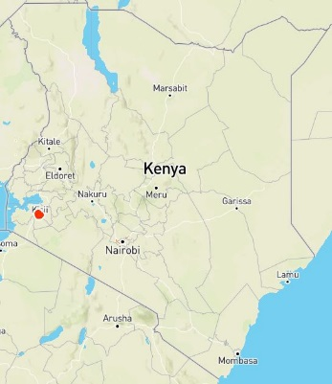
Map of Kenyas
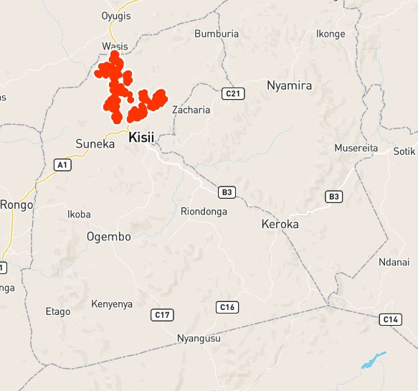
Kitutu Chache south sub-county
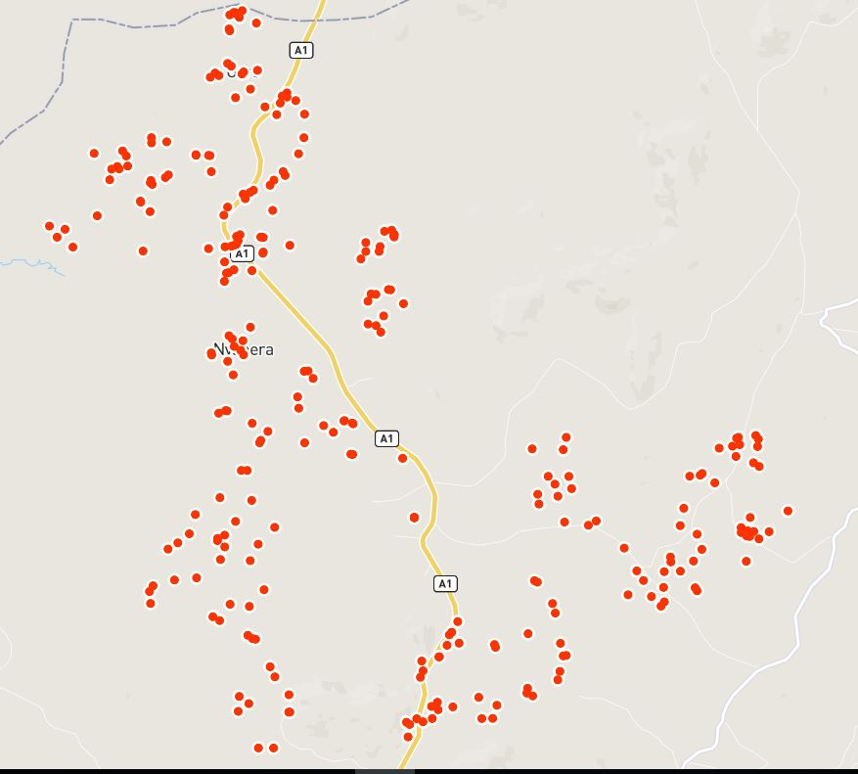
- The red dots represent the sampled households

Annex 3: Example of filled cluster control form
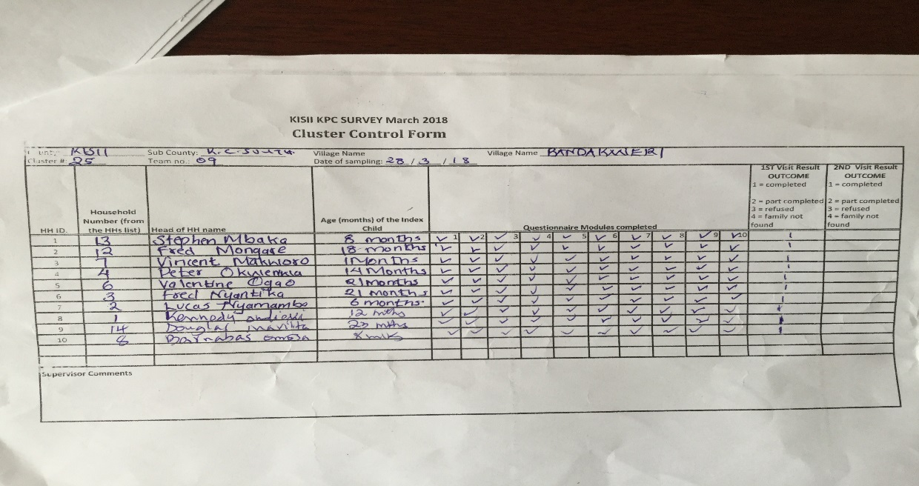

Annex 4: Movement plan and contacts

Annex 5: Calendar of events
MONTH  (Omotienyi) | 2016 | 2017
JANUARY  ‘Engatiato’ | New year/Back to school  Emeyega y’omwaka omoyia na kogenda esukuru. | New year/Back to school  Emeyega y’omwaka omoyia na kogenda esukuru.
FEBRUARY  ‘Monuguno O’Barema’ | Land preparation  Rirema | Land preparation  Rirema
MARCH  ‘Egatamo’ | Onset of rains and planting.  Ogochaka kwebura na gosimeka | Onset of rains and planting.  Ogochaka kwebura na gosimeka.
APRIL  ‘Rigwata’ | School Holiday  Erusa neriburuga. | School Holiday  Erusa neriburuga.
MAY  ‘Amaumuntia’ | Opening of schools  Okoigorwa gwechisukuru | Opening of schools  Okoigorwa gwechisukuru.
JUNE  ‘Ebwagi’ | Harvesting of beans  Rigesa riechinyende | Harvesting of beans  Rigesa riechinyende
JULY  ‘Enkoromoni’ | Flowering of maize and finger millets.  Ogosomoria na kobereka gwechibando | Flowering of maize and finger millets.  Ogosomoria na kobereka gwechibando
AUGUST  ‘Riete’ | Camp meetings  Chikambi | General election and Camp meetings.  Chikura. Chikambi
SEPTEMBER  ‘Tureti ya Kebaki’ | Harvesting and Planting.  Kogesa na gosimeka. | Harvesting and Planting.  Kogesa na gosimeka.
OCTOBER  ‘Esagati  (Sagati Ya Magonga)’ | Start of KCSE examinations  amatemuaclasiisano na isato  Weeding season for short rains  Riburuga | Repeat General elections.  Omoiroro bw’chikura.
NOVEMBER  ‘Egesunte  (Egesunte Gia Chache)’ | Examinations.  Amatemwa. | Examinations.  Amatemwa.
DECEMBER  ‘Egesunte Kende  (Egesunte Kia Masaba)’ | Christmas and circumcision.  Esuguku amo nabana gochia maguta motwe. | Christmas and circumcision.  Esuguku amo nabana gochia maguta motwe.

Annex 6: Training schedule for survey team
Time | Session |  |  |  |  | Expected output
8.00 – 9.00am | Introductions and expectations, setting ground rules/norms, logistics, Pre-test (quiz), nomination of group leaders & daily rapporteurs |  |  |  |  | The facilitators will understand the participants’ background and experience with data collection as well as manage their expectations.
8.30am – 9.00am | Overview of;  - The CBC project  - KPC survey, purpose & Objectives |  |  |  |  | The participants have broader understanding of the project and purpose of KPC
9.00 – 10.00am | Research/survey Ethics & etiquette  - Interviewing techniques  - Seeking consent  - Engaging the respondent  - Listening |  |  |  |  | The participants are aware of research ethics when dealing with human subjects, code of conduct and dressing code
10.00 – 10.45am | Survey questionnaire and translation to Kiswahili and Kisii dialect;  - Identifiers, calendar of events  - Modules 1,2,3 |  |  |  |  | The participants understand the questionnaire modules, questions, and how to ask the questions in local language
10.45 – 11.00am
11.00 – 12.00 noon | Survey questionnaire cont’d  - Modules 4&5 |  |  |  |  | The participants understand the questionnaire modules, questions, and how to ask the questions in local language
12.00 – 1.00pm | - Modules 6,7&8
1.00 – 2,00pm | Lunch
2.00 – 3.00pm | Survey questionnaire cont’d  - Modules 9&10
3.00-4.00pm | Malnutrition, Introduction to anthropometry & equipment  - Weight  - Length/height  - MUAC |  |  |  |  | The participants are knowledgeable on indices to measure malnutrition and parameters involved to calculate prevalence of malnutrition
4.00 – 4.15pm | Tea Break
4.15– 5.00pm | Anthropometry cont’d
Day 2; Tuesday, 20th March 2018
8.00am-8.30am |  | Recap
 |  | Survey design  - Segmentation and Random Number Table  - Sampling frame (hh lists), sampling unit(eligibility)  - Household selection, randomization  - Community entry |  |  |  | The participants understand the survey design – cluster selection, use of random numbers and selection of mothers with children 0-23 months | James
8.30 - 9.00am |  | Tablet instruction  - Logging in  - Rules for tablet use |  |  |  | The enumerators/supervisors are have skills for proper use the tablets and safety. | Mary
9.00 – 9.45am |  | Introduction to in tablets, ODK and questionnaire design  - Getting a blank form  - Filling a blank form  - Sending finalized form  Editing/Deleting saved form |  |  |  | The participants are aware of the features of online questionnaire in the ODK format. | Mary
9.45 -10.30 |  | Questionnaire design  - Opening and administering the survey in ODK - demonstration  - ODK dry-run session 1 (in pairs)  - Saving the surveys –use simulated respondent information |  |  |  | The participants are able to access the questionnaire, fill, send and edit saved forms | James/Mary
10.30 – 10.45am |  | Tea Break
10.45 -11.30am |  | - ODK dry run Session 2 (Individual) |  |  |  | The participants have advanced skills to follow the sequence of questions and Skips for different modules.
11.30 – 12noon |  | Discussion and feedback on live testing of ODK questionnaire |  |  |  |  | James/Mary
12.00 – 1.00pm |  | Eligibility for anthropometry  Preparation for Standardisation test |  |  |  | The participants understand the importance of accurate anthropometric measurements. | James
1.00 -2.00pm |  | Lunch Break
2.00 – 3.00pm |  | Standardisation Test |  |  |  | Enhanced skills for taking accurate measurements, and areas of weakness are identified for improvement | James
3.00 - 4.00pm |  | Plenary  - Experiences, challenges  - Feedback of standardisation results – teams performance |  |  |  |  | All
4.00 – 4.15pm |  | Tea Break
4.15 -5.00pm
Day 3: Wednesday, 21st March 2018
8.00-8.15am |  |  |  |  | Recap
8.15 – 8.45am |  |  |  |  | ODK dry run session 3
8.45 - 9.00am |  |  |  |  | Tea Break/packed lunch
9.00 – 3.00pm |  |  |  |  | Field pilot/pre-test of the questionnaire | The enumerators/supervisors enhance skills on administering the whole questionnaire using the tablets – selecting eligible respondent, informed consent, interviewing the respondent and flow of the questionnaire. | James/All
3.30 -3.45pm |  |  |  |  | Tea Break
3.45 – 5.00pm |  |  |  |  | Feedback from the pilot  - Experiences, challenges from enumerators  - Reports by supervisors  - Plausibility checks for Anthropometry  - Completeness of questionnaire  - Referral slip | Challenges encountered by enumerators/supervisors are identified and addressed.  The time needed to administer the hh questionnaire and take anthropometry measurements is determined for survey planning. | Mary/James
Day 4: Thursday, 22nd March 2018
8.00 – 830am |  |  | Recap
8.30 - 9.15am |  |  | Parallel Sessions  - Supervisors  - Introduction to teams supervision and monitoring plan with the supervisors  - Cluster control form |  |  | Supervisors gain knowledge and skills for effective supervision and survey leadership in the field | James
 |  |  | Enumerators  - Practice sessions on the ODK questionnaire and trouble shooting  - Translations to local language |  |  | Enumerators familiarize themselves with the survey questionnaire and translated versions into Kiswahili/local language. | Mary/Ann
9.15 – 9.45am |  |  | Roles and responsibilities of;  - Enumerators  - Supervisors |  |  | Supervisors and enumerators understand their roles and how to undertake them efficiently | James
9.45 – 10.30am |  |  | Team formation
10.30 – 10.45am |  |  | Tea Break
10.45 – 12.00 noon |  |  | Questionnaire review and translations |  |  | Enumerators have mastery of the questionnaire flow, skips and eligibility. | Mary/Ann
12.00 – 1.00pm |  |  | Preparation for 2nd pilot
1.00 -2.00pm |  |  | Lunch
2.00 – 3.45pm |  |  | Practice identified areas of improvement: Last minute team preparations for 2nd pilot |  |  |  | Kevin
3.45 – 4.00pm |  |  | Tea Break
4.00 – 5.00pm |  |  | Logistics for 2nd pilot |  |  | Participants, supervisors and Curamerica staff understand requirements of pre-test of questionnares.
Day 5; Friday, 24th March 2018
8.00 – 8.30am |  |  |  | Recap
8.30 -8.45am |  |  |  | Tea Break
8.45 – 1.00pm |  |  |  | 2nd Field Pilot with final questionnaire |  | The enumerators are competent to undertake the survey data collection seamlessly form start to end within stipulated time. | James/All
1.00 – 2.00pm |  |  |  | Lunch
2.00-3.00pm |  |  |  | Feedback
3.00 – 4.00pm |  |  |  | Finalization of field work arrangements/preparations  - Team formation and cluster allocation  - Vehicle allocation  - Confirming teal have necessary items by use of checklist  - Returning all the tablets for performance check, settings, charging and preparation for data collection |  | All necessary arrangements for the fieldwork are put in place for a successful data collection. | Kevin/All
4.00 - 4.15pm |  |  |  | Tea and departure

Annex 7: Sampled villages

Annex 8: Work plan

Annex 9: Group photo
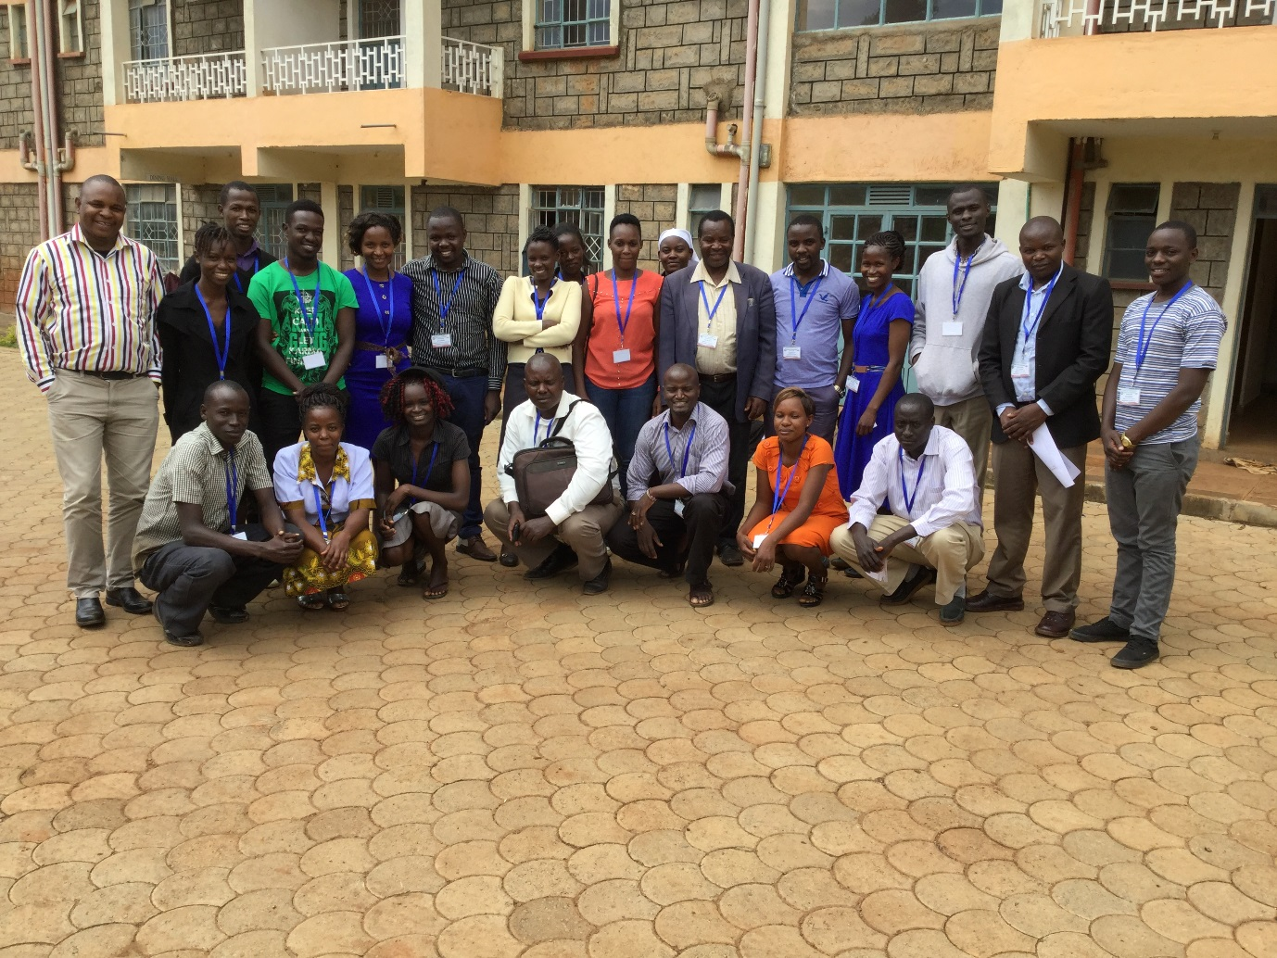
KPC survey team

Annex 10: ODK setup
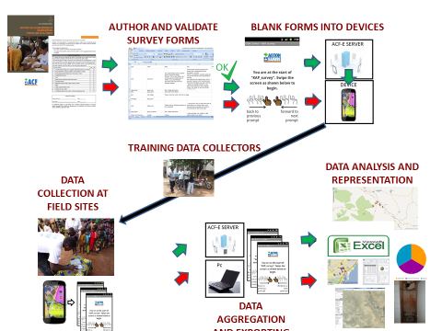

The question on ANC checks/visits was only administered to mothers with MCH handbook. Those mothers without MCH handbook were not asked this question and but were included in the denominator.
http://microdata.worldbank.org/index.php/catalog/2660
https://www.researchgate.net/publication/274391423
Community Birthing Center Model

